##### maxresdefault.jpg

##### Chaonan shi，

BeiMing Liu

Xiaohan Hou

Li Xiao

# Overview

Based on the background and situations, we realized that the question about ABS is asking the differences between the distressed asset and normal asset. The yield from distressed asset and normal asset are different. By definition, distressed asset is an asset that is put on sale, usually at a cheap price, because its owner is forced to sell it, making distressed asset attractive because of the potential appreciation in price. For normal assets, majority of yield is the annual payment, in other words, the rental income, for example the housing located in San Francisco generally has higher rental than other cities but the asset appreciation could be lower than other cities. Also the risk will have various impacts for each assets, such as rental income variability, macro recession, inflation, political changes, etc.

Both of the ABS and the bond yield based on the future cash flow, for example the majority of yield from bond is the debt from companies, and the majority of yield from ABS is the debt from individuals,in other words,the type of loans. also whatever the ABS and the bond both of them yield higher than the GOV treasury bill.

On the other hand, Both of the ABS and the bond face similar risk: credit risk, interest risk, and yield risk. For example, ABS also carry some prepayment risk(credit risk), which is the chance that investors will experience reduced cash flows caused by borrowers paying off their loans early, particularly in a declining interest rate environment, when borrowers can refinance existing loans with new, lower interest-rate loans.

For investors, risk averse investor and risk love investor will receive different yield and cash flow, even they invest in the same amount of money with similar property. For example, higher default rate for ABS always has higher yield compare with lower default rate ABS and the uncertainty factors(weather, political change, rental rate etc) will have larger impact for risk love investor than risk averse investor because the cash flow can be prioritized. In this project we assume investors receive different amount of money according to the risk tolerance rate.

Beside the ABS and investors, we also need consider about the macro scenarios, what if the economy is recession, stable, and blooming. Under the different situation, the risk and yield could be different. For example in the economy recession period, the default rate could be higher than other situations, and in the economy blooming period, the rental income could be higher than other situations. For reflect situations as accuracy as possible, we assume growth rate, rental income, and vacancy rate is different in each scenarios. And based on these differences, the ABS’s yield, duration, and expected total return is different.

Thus according to the above analysis, we decided to construct different cash flow sheet for different investors and for different scenarios. We will also analyse how factors influence the cash flow for investors not only the risks but also the benefits.

For this project, we would like choose the assets located in the San Jose, 57 miles far from San Francisco.

Generally the housing located in San Jose, for example 2b2b, worth $628K in 2017.And the median home value in San Jose is $852,200 in 2017. San Jose home values have gone up 4.3% over the past year.The median list price per square foot in San Jose is $501. The median price of homes currently listed in San Jose is $765,000. The median rent price in San Jose is $3,100.

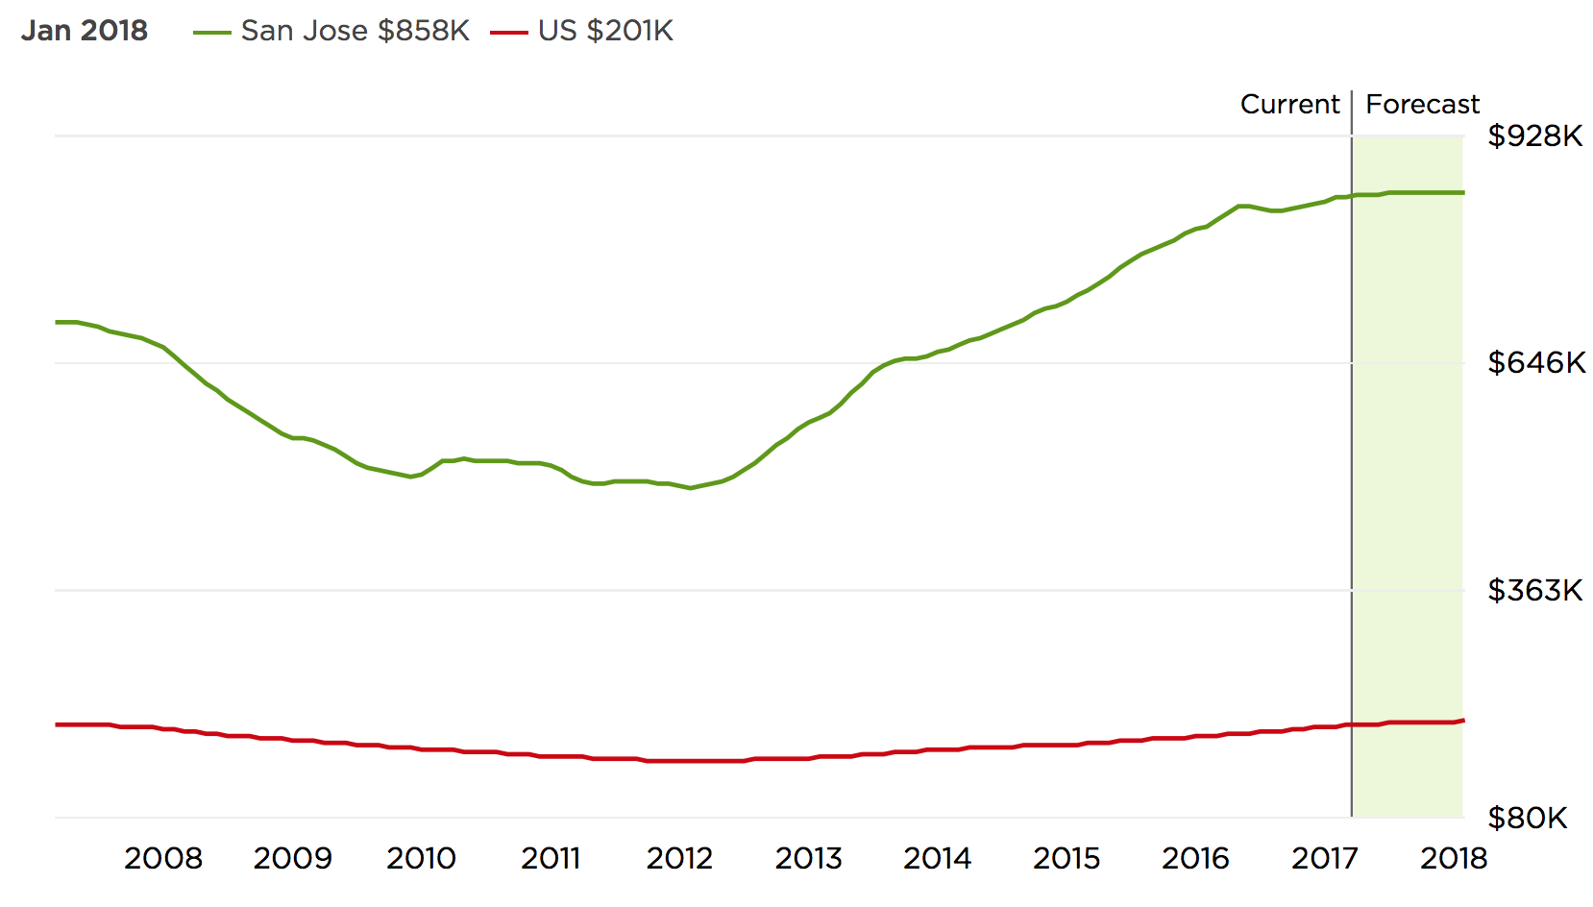

(From Zillow.com)

On the other hand, San Jose is one of most popular city in the US. San Jose's location within the booming [high tech](https://en.wikipedia.org/wiki/High_tech) industry, as a cultural, political, and economic center has earned the city the nickname "Capital of [Silicon Valley](https://en.wikipedia.org/wiki/Silicon_Valley)". San Jose is one of the wealthiest major cities in the United States and the world, and has the third highest GDP per capita in the world (after [Zurich, Switzerland](https://en.wikipedia.org/wiki/Zurich,_Switzerland) and [Oslo, Norway](https://en.wikipedia.org/wiki/Oslo,_Norway)), according to the [Brookings Institute](https://en.wikipedia.org/wiki/Brookings_Institute).

From the above information, we predict the value of housing located in San Jose less likely becomes lower.

# Explanation:

Throughout the past 10 years, the San Jose housing price has been increased 22.7%(From Feb, 2007 at $696K to Mar,2008 at $858K); compare with the US housing price has been increased 0.0%(From Feb, 2007 at $196K to Mar,2008 at $196K).

We also predict the housing price from San Jose will appreciate in the next 10 years in 2 ways:

* + First we choose P/R ratio(price to rental) to predict the future cash flow and the macroeconomic trends. The median price of homes currently listed in San Jose is $765,000 and The median rent price in San Jose is $3,100, thus the P/R ratio is $765,000/$37,200(annual), around 20.56. Because we have to consider potential risk and uncertainty loss, so we need prepare some reserve against those losses, in this case, we prepare one million reserve for potential loss:

Then use $9,000,000 divided by 20.56: $9,000,000/20.56=$437743.19(annual cash flow);

$437743.19/12=$36478.6(monthly);

Thus the future cash flow for investing in $9,000,000 at San Jose would be: $36478.6(monthly);

The San Jose tax rate is:0.794%

The biggest real estate website, Zillow, predict housing will rise 0.7% within the next year in San Jose compare with the US housing will rise 0.4%.

Based on the above expectations, we predict our asset unwind value at the end of 10-year holding period will be:

FV=PV(1+g)^10=$9,000,000[1+(0.7%+0.4%)/2]^10=$9,507,432.68.

* + Second way is constructing traditional cash flow to estimate future cash flow, we also carry out the stress test for different economy circumstances: Recession, Blooming, And Stable.

|  |  |  |
| --- | --- | --- |
| Property |  | $9,000,000 |
| unit |  | 50 |
| Rent/Month |  | $2,900 |
| Month/Year |  | $12 |
| Expect growth rate at the end of 10th year | | 0.7% |
| year10 sales price |  | $9,650,220 |
| selling expense |  | $836,674 |
| **net receipts** |  | $8,813,546 |
| book value |  | $7,714,286 |
| net profit |  | $1,099,260 |
| **taxes (20%)** |  | $219,852 |
| **net cashflow** |  | $8,593,694 |
| According to above informations, we assume that the ecomomy circumstance is relatively stable .(growth rate around 0.7% and average vacancy rate around 8% and keep constant in next 10 years)： |  |  |

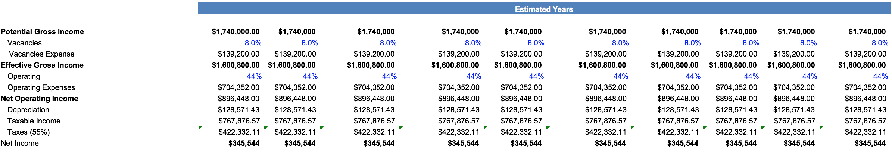

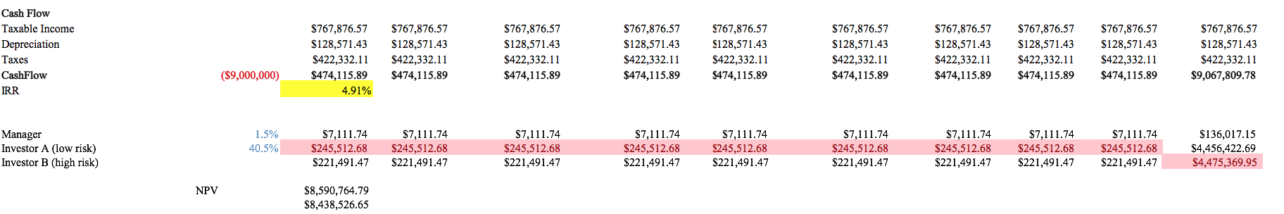

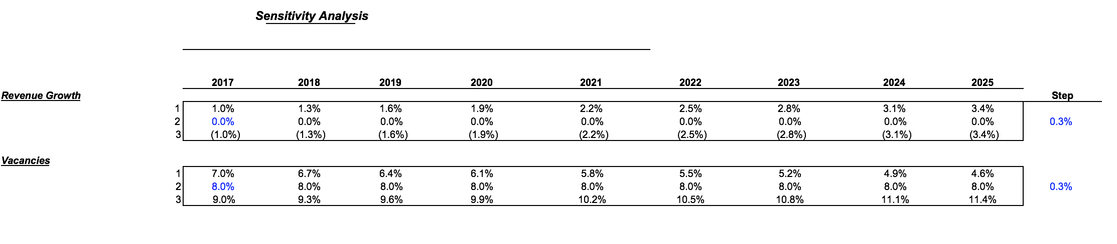

MOD DURATION：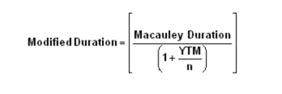=7.55(for risk lover)

= 7.87(for risk averse)

If we assume that the ecomomy is blooming (growth rate around 3% and average vacancy rate decreases continuously)：

|  |  |  |
| --- | --- | --- |
| Property |  | $9,000,000 |
| unit |  | 50 |
| Rent/Month |  | $2,900 |
| Month/Year |  | $12 |
| Expect growth rate at the end of 10th year | | 3.0% |
| year10 sales price |  | $12,095,247 |
| selling expense |  | $1,048,658 |
| **net receipts** |  | **$11,046,589** |
| book value |  | $7,714,286 |
| net profit |  | $3,332,304 |
| **taxes (20%)** |  | **$666,461** |
| **net cashflow** |  | **$10,380,129** |

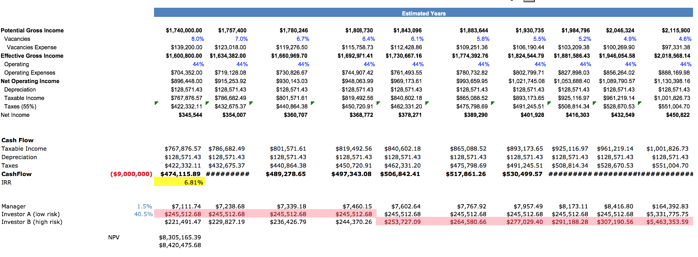

MOD DURATION：=10.21 (for risk lover)

= 8.7 (for risk averse)

If we assume that the ecomomy circumstance is relatively recession (growth rate around -3%, and average vacancy rate around 9.98% and increase year after year )：

|  |  |  |
| --- | --- | --- |
| Property |  | $9,000,000 |
| unit |  | 50 |
| Rent/Month |  | $2,900 |
| Month/Year |  | $12 |
| Expect growth rate at the end of 10th year | | -3.0% |
| year10 sales price |  | $6,636,817 |
| selling expense |  | $575,412 |
| net receipts |  | $6,061,405 |
| book value |  | $7,714,286 |
| net profit |  | $(1,652,881) |
| taxes (20%) |  | $(330,576) |
| net cashflow |  | $6,391,981 |
|  |  |  |

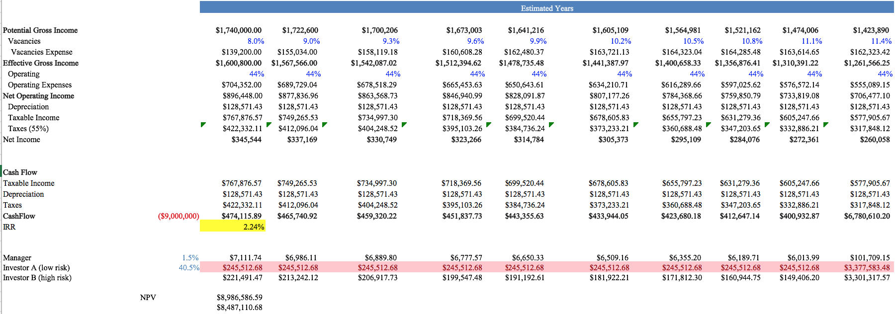

MOD DURATION：=5.66 (for risk lover)

= 7.04 (for risk averse)

Conclusion:

From the changes in cash flow sheet, we can easily find if the economy circumstances change from one to another, the future value and the IRR will change dramatically due to the cash flow receive differently. Also under the different economy scenarios, ABS’S duration, yield, and expected total return are clearly reflect in the 10 years cash flow sheet.

According to the cash flow sheet we created, from our point of view, there are two ways to use extra cash reinvest:

First one is purchasing the 10-year treasury bonds. 10-year treasury bonds can avoid credit risk from ABS, however the yield from 10-years treasury bond might cannot make investor satisfied expecially for higher risk tolerance investor.

Second one is reinvesting in ABS. The benefits from reinvesting in ABS is that the investors can enjoy higher yield from IRR. However the investors who decide to reinvest in ABS also face higher credit risk than 10-years treasury bonds.

# Risks & loan:

However the potential risk like prepayment risk, political risk, internet bubble, etc, will still have phenomenal impact for housing price. For instance, if Present Donald Trump implement the policy to prevent immigrant move in to the US, I believe thousands of programmers and thousands of students will move out from the US. In this case, based on the demand and supply theory, the San Jose housing price could decrease in the future. Indeed, due to the lots of technology companies located in or next to San Jose, if internet bubble happens again, the San Jose housing price also could become lower in the future. In this case, if future price of asset becomes lower, then the rental income will become lower and monthly cash flow become lower, too. As the results the yield of ABS based on the asset will decrease and investor likely face prepayment risk.

Moreover what if the investors tend to invest in high quality asset generally more valuable asset can provide more rental income in each month.Thus we consider that if we use mortgage for our investment:

Under the ecomomy circumstance is relatively stable .(growth rate around 0.7% and average vacancy rate around 8% and keep constant in next 10 years)：

|  |  |  |
| --- | --- | --- |
| Property |  | $60,000,000 |
| Loan Amount |  | $60,000,000 |
| Downpayment |  | $10,000,000 |
| Terms |  | $45 |
| Interest rate |  | 3.25% |
| Annual payment |  | $2,951,640 |
| unit |  | 150 |
| Rent/Month |  | $2,900 |
| Month/Year |  | $12 |
| Expect growth rate at the end of 10th year | | 0.7% |
| Payoff loan amount |  | $42,914,916 |
| year10 sales price |  | $64,334,800 |
| selling expense |  | $2,573,392 |
| net receipts |  | $61,761,408 |
| book value |  | $51,428,571 |
| net profit |  | $10,332,837 |
| taxes (20%) |  | $2,066,567 |
| net cashflow |  | $59,694,841 |

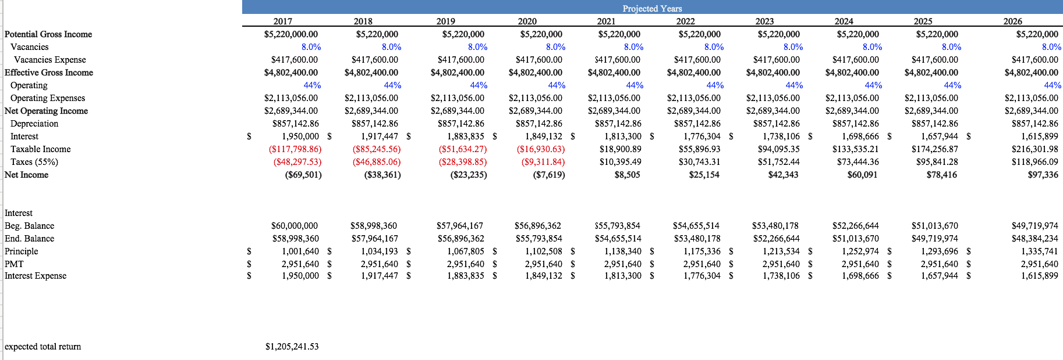

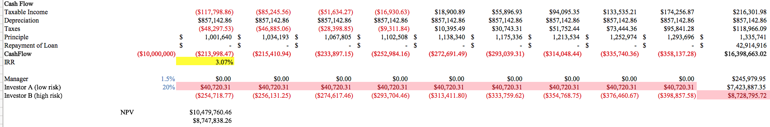

MOD DURATION：=9.73 (for risk lover)

= 8.11 (for risk averse)

Under the ecomomy circumstance is blooming .(growth rate around 3% and average vacancy rate around 6.02% and decrease year after year )：

|  |  |  |
| --- | --- | --- |
| Property |  | $60,000,000 |
| Loan Amount |  | $60,000,000 |
| Downpayment |  | $10,000,000 |
| Terms |  | $45 |
| Interest rate |  | 3.25% |
| Annual payment |  | $2,951,640 |
| unit |  | 150 |
| Rent/Month |  | $2,900 |
| Month/Year |  | $12 |
| Expect growth rate at the end of 10th year | | 3.0% |
| Payoff loan amount |  | $42,914,916 |
| year10 sales price |  | $80,634,983 |
| selling expense |  | $3,225,399 |
| net receipts |  | $77,409,583 |
| book value |  | $51,428,571 |
| net profit |  | $25,981,012 |
| taxes (20%) |  | $5,196,202 |
| net cashflow |  | $72,213,381 |

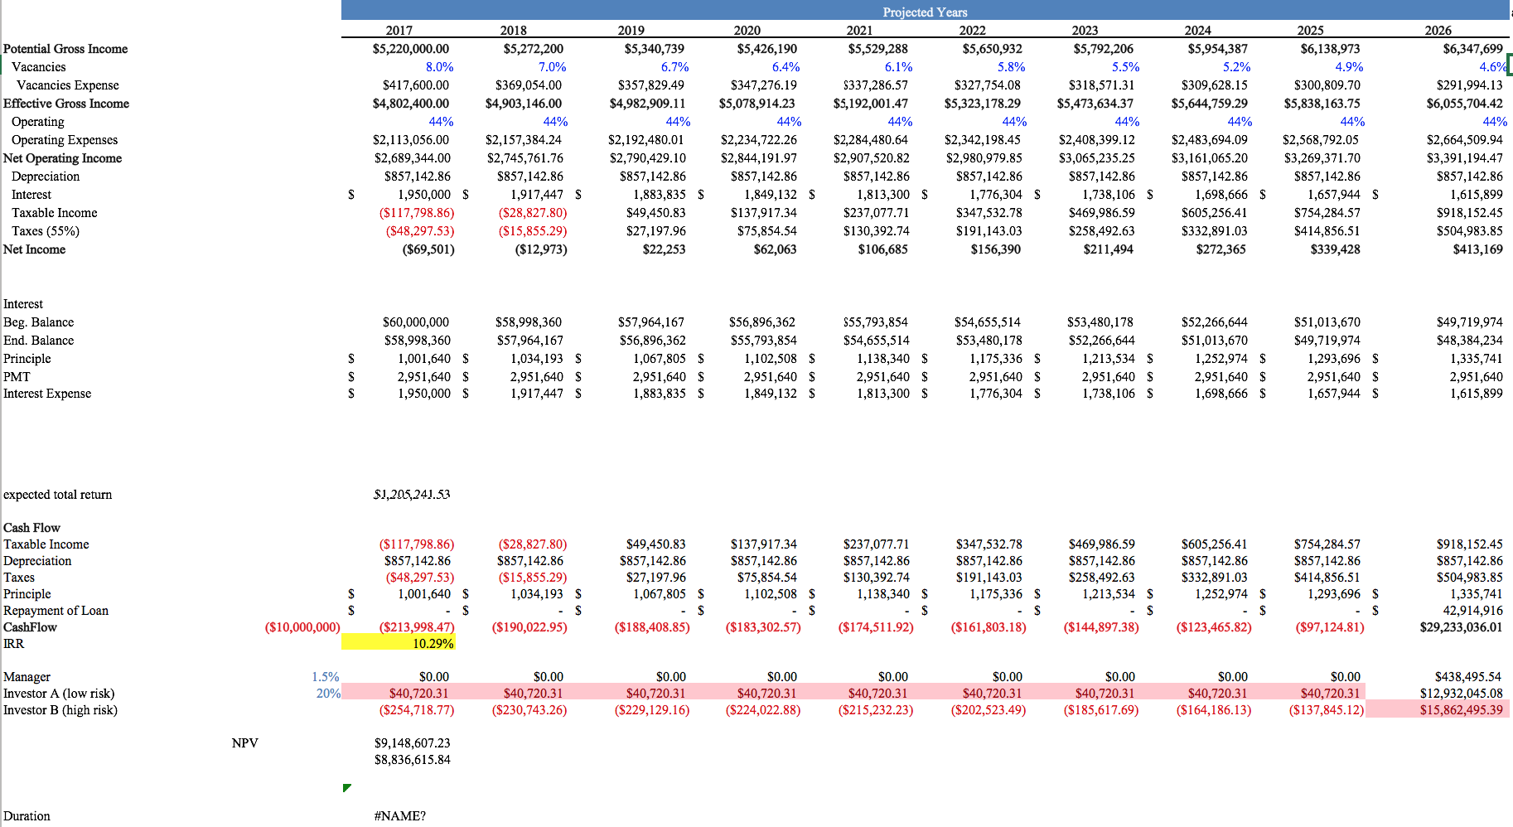

MOD DURATION：=12.32 (for risk lover)

= 10.98 (for risk averse)

Under the ecomomy circumstance is relatively recession .(growth rate around -3% and average vacancy rate around 9.98% and increase year after year)：

|  |  |  |
| --- | --- | --- |
| Property |  | $60,000,000 |
| Loan Amount |  | $60,000,000 |
| Downpayment |  | $10,000,000 |
| Terms |  | $45 |
| Interest rate |  | 3.25% |
| Annual payment |  | $2,951,640 |
| unit |  | 150 |
| Rent/Month |  | $2,900 |
| Month/Year |  | $12 |
| Expect growth rate at the end of 10th year | | -3.0% |
| Payoff loan amount |  | $42,914,916 |
| year10 sales price |  | $44,245,448 |
| selling expense |  | $1,769,818 |
| net receipts |  | $42,475,630 |
| book value |  | $51,428,571 |
| net profit |  | $(8,952,942) |
| taxes (20%) |  | $(1,790,588) |
| net cashflow |  | $44,266,218 |

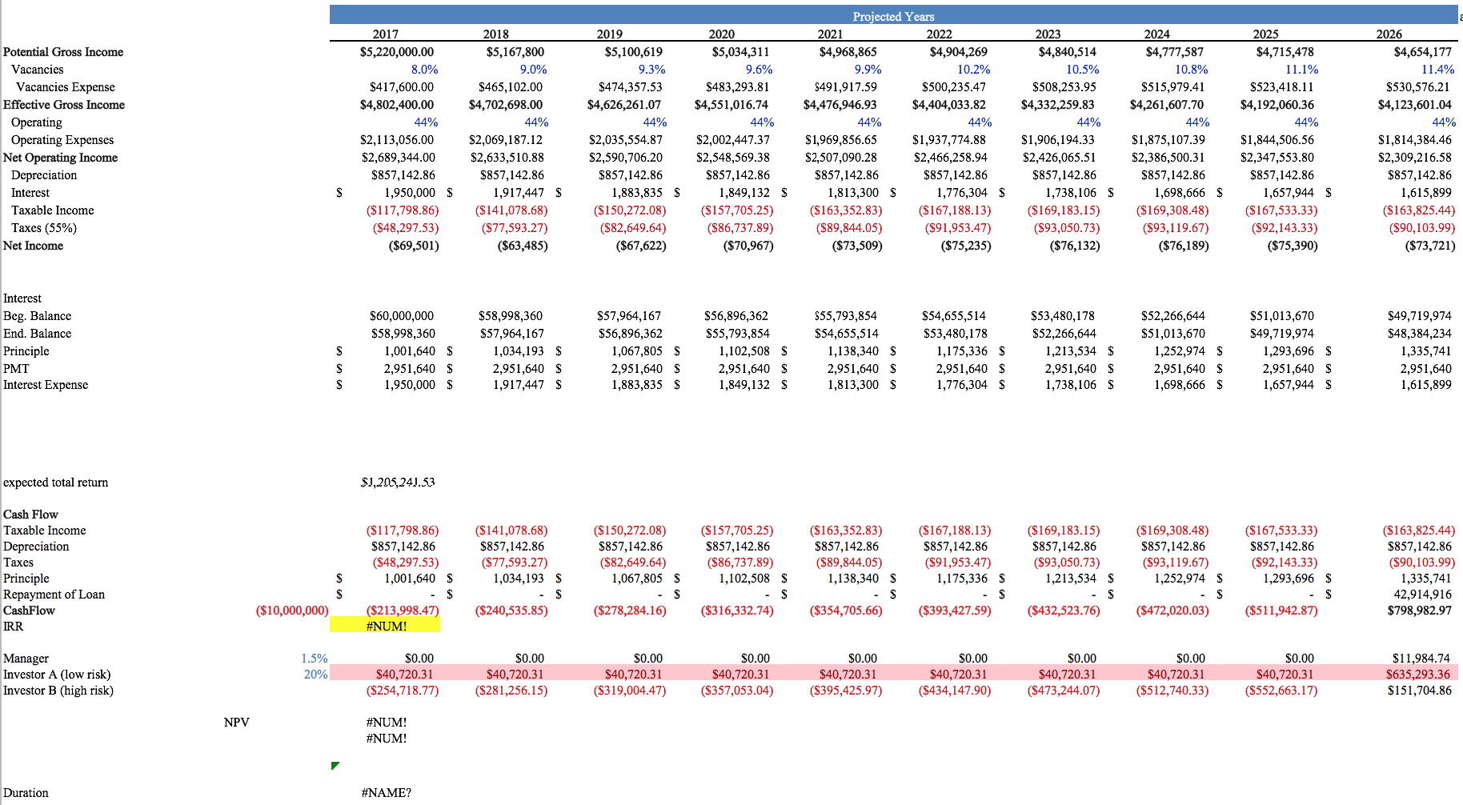

MOD DURATION：=3.1 (for risk lover)

= 6.46(for risk averse)

Conclusion:

From the changes in cash flow sheet, we can easily find if the economy circumstances change from one to another, the future value and the IRR will change dramatically due to the cash flow receive differently. Also under the different economy scenarios, ABS’S duration, yield, ant expected total return are clearly reflect in the 10 years cash flow sheet.

Moreover, the mortgage can be pretty dangerous if economy into recession period. Based on the IRR and NPV formula we can easily understand that if expected future growth rate become negative, the yield from rental income will offset by interest rate. In this case the investor could lose money if they invest in the ABS which based on the mortgage asset.

So from my point of view, in case of using mortgage, only when investor require invest in the big asset. Otherwise there are higher risk for ABS, and make ABS become less valuable. On the top of that, investors could have negative yield from ABS.

# Risk analysis:

For analysis how risk factors influence the housing price, we decided to construct model to predict the significance for housing price. In this case we select Interest rate, CPI, and GDP as independent variables and select housing price index as depended variable:

10 years treasury bonds: represent the interest and interest rate represent money supply and value of treasury bonds;

CPI: use CPI to capture the inflation rate;

GDP: to estimate the national macro trend;

Regression:



R^2 = 0.425 means the variable only explain 42.5% information for depended variable;

T test for 10-years treasury bonds:



H0:βi=0

H1:βi≠0

Reject H0 if Tfit>T-critical at 95%

Hypothesis test for independent variables 1 – USG 10 years

𝐻0: 𝛽1 = 0 𝐻1: 𝛽1 ≠ 0

Test Statistic: 𝑡̂ = 𝛽1−0/s = 36.79

Decision Rule: Reject 𝐻0, if 𝑡̂ > t-critical at 5% significance level According to the t-critical value table, 𝑡̂ > t-critical: reject 𝐻0 ; so the interest rate have huge impact to housing price.

Hypothesis test for independent variables 2 – CPI



𝐻0: 𝛽1 = 0 𝐻1: 𝛽1 ≠ 0

Test Statistic: 𝑡̂ = 𝛽1−0/s = 14.54

Decision Rule: Reject 𝐻0, if 𝑡̂ > t-critical at 5% significance level According to the t-critical value table, 𝑡̂ > t-critical: reject 𝐻0 ; so the CPI have impact to housing price, but have less impact than interest rate.



𝐻0: 𝛽2 = 0 𝐻1: 𝛽2 ≠ 0

Test Statistic: 𝑡̂ = 𝛽1−0/s = 14.54

Decision Rule: Reject 𝐻0, if 𝑡̂ > t-critical at 5% significance level According to the t-critical value table, 𝑡̂ > t-critical: reject 𝐻0 ; so the CPI have impact to housing price, but have less impact than interest rate.



𝐻0: 𝛽3 = 0 𝐻1: 𝛽3 ≠ 0

Test Statistic: 𝑡̂ = 𝛽1−0/s =9.03

Decision Rule: Reject 𝐻0, if 𝑡̂ > t-critical at 5% significance level According to the t-critical value table, 𝑡̂ > t-critical: reject 𝐻0 ; so the GDP have impact to housing price.

We also predict the dependent variable’s residual to estimate the future housing trend:



Moreover, we use correlation rate to estimate the relationship between Housing price and other factors:



In the results, the interest rate and housing price correlation is negative, it means when interest rate go down, the price of house goes up. From my point of view, investors are willing to financing the house when interest rate relatively low;

The CPI and housing price correlation is negative, it means when inflation become higher, the price of house goes down. From my point of view, investors are willing to invest in stock and other higher yield product.

The GDP and housing price correlation is positive, it means when GDP goes down, the price of house goes up. Higher GDP means higher income, it is easily understand why the correlation between the GDP and housing price is positive.

# In The Summary :

According to the above analysis. We can find what the relationship between the risk and the yield and what what the relationship between the marco scenarios and the duration. Furthermore, we also construct the model for predicting the housing price and how risk factors influence the housing price. Finally, we can summarize several categories for ABS:

1: The ABS more likely the MBS. The security we need to design is really similar to a bond as investors would receive dividends in each period holding ABS and principal payment at the end of the holding periods.

2: The majority of source of cash flow come from 3 parties: expected future cash flow, expected future fair market value of housing, and the extra money from reinvestment.

3: The majority of source of risk for ABS comes from 2 parties: the Macro trend and the fluctuation of the real estate market.

4: For mortgage part: The only reason that we use mortgage to create ABS is that the investors require higher yield and basically we don't have enough fund to hit the requirement. Or there is an asset we cannot afford.

5:About the separate properties: Tranche A is designed for risk averse and Tranche B is designed for risk lover. Tranche A is less risky than tranche B, which means the investor in tranche B will receive higher portion of the net investment income. However, if the bad case happens, the tranche B also lose higher portion of the net investment income than the tranche A. And any excess return from expected future cash flow will distribute to the tranche B investor.